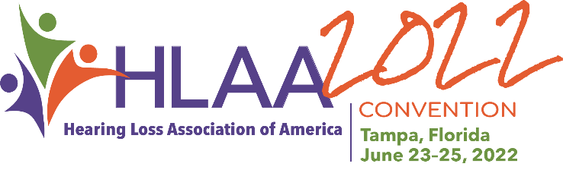
Instructions for Call for Papers

The Hearing Loss Association of America (HLAA) is soliciting workshop proposals for
HLAA2022 to be held June 23-25 at the JW Marriott Tampa Water Street. Workshops will be scheduled for June 23, 24 and 25. Presenters should be prepared to present on any of these dates. The proposal deadline is Friday, December 10, 2021.

Workshops will be one hour in duration—you should plan to leave time for Q&A and discussion. Presenters should plan on sending their PowerPoint presentation for posting in the Convention mobile app (posted as a PDF) by May 20, 2022, and bringing handouts of their presentation for 50 attendees; handouts may also be posted in the Convention mobile app. Your presentation is also given to a CART provider to help them prepare in advance for your session.

Goals for the Education Program
Traditionally, our education program has reflected our mission: to open the world of communication to people with hearing loss through information, education, support and advocacy. The program is designed to include workshops on a variety of topics.

Options for workshop topics include, but are not limited to:
- Hearing Assistive Technology (HAT)
- Advocacy
- Lifestyle
- Hearing Health
- Employment and the Workplace
- Family
- Spanish Speaking

Disclosure Statement
Disclose any and all, real or potential conflicts of interest. Name any and all professional, financial, or personal affiliations which may cause the impression that bias or prejudice could affect the objectivity of material presented. Affiliations do not automatically disqualify a potential presenter.

Learning Objectives
Please submit three learning objectives and clearly identify the outcomes or actions that attendees can expect to demonstrate as a result of attending the proposed workshop. Learning objectives should complete the following sentence: Upon completion of this workshop, the participant will be able to…. Begin each objective with a measurable action-verb that describes the performance of the learner. Apply, describe, analyze, assess, choose, discuss, or demonstrate are a few verbs that illustrate performance.

Do not start your learning objective with an immeasurable action verb such as understand, learn, or know. Proposals that do not include measurable learning objectives will not be considered.

Convention Mobile App
The mobile app contains a wealth of information including schedules, exhibitors, sponsors, maps and speakers. Upon approval, a profile will be set up in the app and include your name, title and company; you will then be sent a link to your profile so that you can customize it with social media links, photo and more—this is a great way for attendees to “get to know” you prior to the Convention and helps drive traffic to your workshop. You may also upload documents, such as handouts.

Presenter Responsibilities (PLEASE READ CAREFULLY):
- Presenters agree to present in English and provide handout materials in English (handouts may also be uploaded to the mobile Convention app).
- Presenters do not receive a stipend from HLAA.
- Presenters are responsible for their own travel and accommodation arrangements.
- Presenters must register for the Convention. Registration is free for all presenters on the day of their scheduled presentation. If they wish to arrive early, or stay beyond the day of their presentation, they may do so by paying the discounted registration fee of $150. Please see the speaker registration form for more information
- Presenters give permission to publish photos of their session.
- Presentations that market specific products and services are not acceptable. If you would like to give a presentation featuring your product, there will be a Demo Room in which product demonstrations will be scheduled (see Proposal for Demo Room Product Demonstration)
- Send your PowerPoint (PPT) (MUST USE HLAA PPT template) to convention@hearingloss.org by May 20, 2022–it will be forwarded to the CART provider for your workshop so that names and terminology may be added to their dictionary. It will also be posted as a PDF to the mobile Convention app-it should contain copyright information.
- Presenters agree to complete their profile on the mobile Convention app (a link is provided to your profile to which you can add your photo, social media contacts, etc.)

Deadline: Friday, December 10, 2021

Contact
Questions may be directed to Amanda Watson, meeting planner at 301.657.2248 Ext. 102, or email awatson@hearingloss.org

A program committee will review all proposals. Not all papers will be accepted due to space limitations. Presenters will be notified via email by the end of January.

