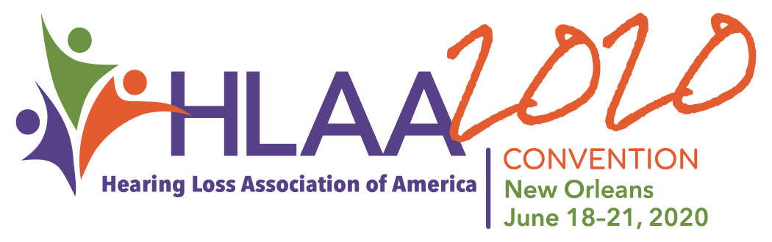
Attendee Name(s)
VOLUNTEER REGISTRATION

What does a General Package include?
- Exhibit Hall Grand Opening, Thursday morning, June 18
- Opening Session, Thursday evening, June 18
- Research Symposium, The Latest on Tinnitus Research, Friday morning, June 19
- Get Acquainted Party (GAP) – Off-site Event, Friday evening, June 19
- HLAA2020 Convention Walk4Hearing, Saturday morning, June 20
- Awards Ceremony and Reception, Saturday evening, June 20
- Unlimited entry to Exhibit Hall and Socials
- All workshops, demo presentations and featured speakers

Select your registration package below:
General Package (Does NOT include optional event tickets)
FIRST-TIMER must be an HLAA Member who has never attended an HLAA Convention in the past.*
 | By 3.2.20 |  |  | By 5.22.20 |  | On-site
Member Individual | $202 |  |  | $247 |  | $292
Member Couple | $314 |  |  | $359 |  | $404
*Member First-Timer | $191 |  |  | $236 |  | $280
*Member First-Timer Couple | $299 |  |  | $345 |  | $389
Member Student | $105 |  |  | $150 |  | $195
Non-Member Student | $131 |  |  | $175 |  | $220
Non-Member | $236 |  |  | $280 |  | $326
Daily Packages
(Saturday evening Awards Reception and Ceremony NOT included in daily package, purchase ticket separately)
 |  | By 3.2.20 | By 5.22.20 |  | On-site
Thursday |  | $94 | $113 |  | $150
Friday (Includes Get Acquainted Party) |  | $94 | $113 |  | $150
Saturday (Includes Awards Ceremony) |  | $94 | $113 |  | $150

Registration Total: $_________
Please RSVP for events included in General Package:
Free!
Free!
Get Acquainted Party (GAP) / Off-site event
An Evening in the Big Easy!
Friday, June 19
Yes # of Tickets:
No
Awards Ceremony and Reception
Saturday, June 20

Yes # of Tickets:
No

Those who are not registered for the convention and wish to attend the above special events:
Additional tickets:
GAP: #tickets ______ @ $30/per person = $
Awards Ceremony and Reception: # tickets ______ @ $30/per person = $

Tickets Total: $__________

Dietary Needs:
Primary Attendee: Vegetarian Low Sodium Diabetic Gluten Free
Second Attendee: Vegetarian Low Sodium Diabetic Gluten Free

Are you a young adult (ages 18-30)? Are you a Veteran? Membership for NEW Veteran Members
Yes No Yes No COMPLIMENTARY one-year Regular and Lifetime Digital Membership
Communication Access at HLAA2020
HLAA will continue to employ realtime captioning during every plenary session and workshop in addition to hearing loops
in all rooms. Sign language interpretation is available during plenary sessions and by request for workshops. All requests must be sent to convention@hearingloss.org by May 22, 2020. Please see the Convention page for more information.

Annual Membership Options New Renewal
Individual $45 Couple/Family $55 Professional $80 Nonprofit $80
Individual $35 (digital only) Student $25 (digital only/enclose copy of student I.D.)

Membership total  Would you like to make a contribution?  Contributions help support the information, education, support, and advocacy efforts of HLAA throughout the year. Donors who contribute to the Convention will be listed in the Convention Program & Exhibit Guide if received by April 15, 2020. | $
Registration total | $
Tickets total | $
Contribution | $
PAYMENT TOTAL | $

Registration Information (please type or print clearly)
Primary Registrant (Name as it will appear on badge) | Secondary Registrant (Name as it will appear on badge
Address | City |  | State | Zip
Email | Phone / Cell Number
Payment Information
Check: make payable to Hearing Loss Association of America
Credit Card American Express Discover Master Card Visa
Card Number |  | Expiration Date MM/YY |  | Security Code
Cardholder’s Name | Cardholder’s Signature
Address | City |  | State | Zip
Billing Address (must be associated with credit card used)
CANCELLATION POLICY
The following policy applies to refunds of registration fees:
- Cancellation on/or before March 2, 2020: Refund = full amount of registration fees and event tickets less a $50 cancellation fee.
- Cancellation between March 2 and April 30, 2020: Refund = 75% of registration fees and event tickets.
- Cancellation between May 1 and May 22, 2020: Refund = 50% of registration fees and event tickets.
- No refunds will be honored after May 22, 2020.
Cancellation must be received in writing.
- Cancellation date will be determined by USPS postmark or email receipt date.
Mail form and payment to:
Hearing Loss Association of America
7910 Woodmont Avenue, Suite 1200
Bethesda, MD 20814
Or fax form to:
301.913.9413
Questions? Call or email us at:
convention@hearingloss.org

Phone 301.657.2248

