iOS Mobile Apps

Category | App | Price | Description | Website
Accessibility | 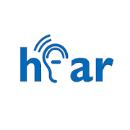  TextHear | Free | Speech-to-text app that can also couple to landline corded phones for captioning output, has bundled pricing after free demo | https://texthear.com/
Accessibility | Ava - 24/7 Accessibility | Free | App that uses voice recognition software and leverages technology that links mobile phones in group situations to allow a person with hearing loss to participate in multi-talker conversations | http://ava.me/
Accessibility | InnoCaption | Free | App for captioning telephone calls and even voicemail. There is also mobile 911 support. It can only be used on your mobile (at this time) and it requires that you register on their website. | http://www.innocaption.com/
Accessibility |  | 1-month free trial, then $9.99/ month | When you download the app and personalize it, your calls are calibrated to your hearing loss, resulting in crystal clear calls.
Accessibility | 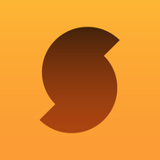  SoundHound | Free | Listens to music to bring up artist, song, album and will also display synchronized lyrics | http://support.soundhound.com/
Accessibility | Musixmatch | Free | App for displaying synchronized lyrics of music in your iTunes library or even music videos on YouTube. | https://musixmatch.helpshift.com/a/musixmatch/?p=ios
Accessibility | Subtitles Viewer! | Free | Access subtitles to movies or TV shows and read them on your iDevice | http://interactivecoconut.com/contact.php
Listening Therapy | 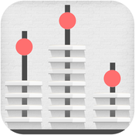  Functional Listening | $14.99 | Auditory exercises with everyday messages in a variety of listening environments | https://www.virtualspeechcenter.com/support/contact
Listening Therapy | Coffitivity | Free | Variety of sounds (e.g., coffee shop, lunch room) that you can use when practicing listening in noise | http://coffitivity.com/
Listening Therapy | i-Angel Sound | Free | Fantastic auditory training tool where you can listen for different contrasts, in a variety of conditions (e.g., quiet, noise) and keep track of your progress. | http://isolutions.emilyfufoundation.org/
Listening Therapy | Hear Coach | Free | Mobile app that gets progressively harder and keeps track of your progress, auditory discrimination tasks include listening to words (then words in noise as it gets harder) and numbers (then numbers in noise as it gets harder - great for phone phobia!) | http://starkey.com/corporate/contact-us
Media Player | DCMP | Free | Watch streamed content (with captions and/or audio descriptions) from the vast library of the Described and Captioned Media Project | http://dcmp.org/contact-us
Personal Amplifier | EarMachine | Free | Nifty app that essentially lets you play around with adjusting loudness and pitch. You can turn things up/down and emphasize highs/lows. There's even a nifty little sound level meter included so you can monitor your environment. You can use it as an amplifier or while you're listening to music. | http://www.earmachine.com/

